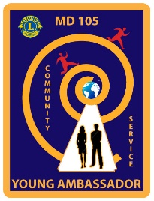

MULTIPLE DISTRICT 105
YOUNG AMBASSADOR
OF THE 21ST CENTURY

Travel Arrangements Consent Form – for Candidates travelling with people other than their parents/guardians

Type of event: _______________________________________________________

Where taking place: __________________________________________________

Time and Date of event: From: _______________ To: ______________________

Name of person attending the event: _____________________________________

Address: ___________________________________________________________

___________________________________________________________________

Date of birth: __________________Telephone Number: ____________________

Travel arrangements- If other than parent and Candidate under 18 years of age, DBS Certificate needed. The driver must be at least 21 years old, have held a full driving for at least 3 years and have no more than 6 penalty points.

Who is providing transport? Name: _______________________________________

Vehicle: ____________________________________________________________

Contact Details: _____________________________________________________

Fully comprehensive Insurance when volunteering Yes/No. Details:

___________________________________________________________________

Who will be present during the journey: __________________________________

__________________________________________________________________

___________________________________________________________________

Name address and telephone number of emergency contact: __________________

___________________________________________________________________

Parent*/Guardian*/Carer* Consent *Delete as applicable

I am willing for (name) ___________________________ to attend the above Lions Club event. I have read the information on this form and I am satisfied with the proposed travel arrangements. I therefore give my consent to these travel arrangements.

Signature: ------------------------------------------------------------- Dated: -------------------------------------

